
Photo is cutting where: URGENT BCP S…. written.

Please affix complete photo and check after applying.

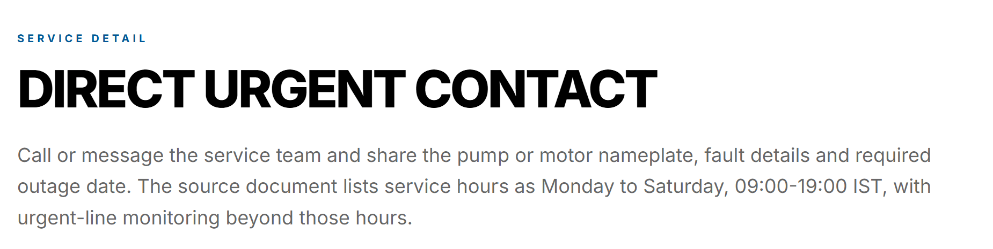
WRITE: DIRECT URGENT CONTACT – ANY DAY, ANY TIME
DELETE THIS LINE from above paragraph: The source document….beyond these hours.


Replace above content: “sales@deivox.co.in, Monday-Sunday, 24X7”

Not required same image at the end of page. Remove this

